### Finding Exploits

### Subtask 1

Fuzz SLmail by finding out how long a password string will crash the program. You should submit the following.

1. A screenshot of the SLMail crashing

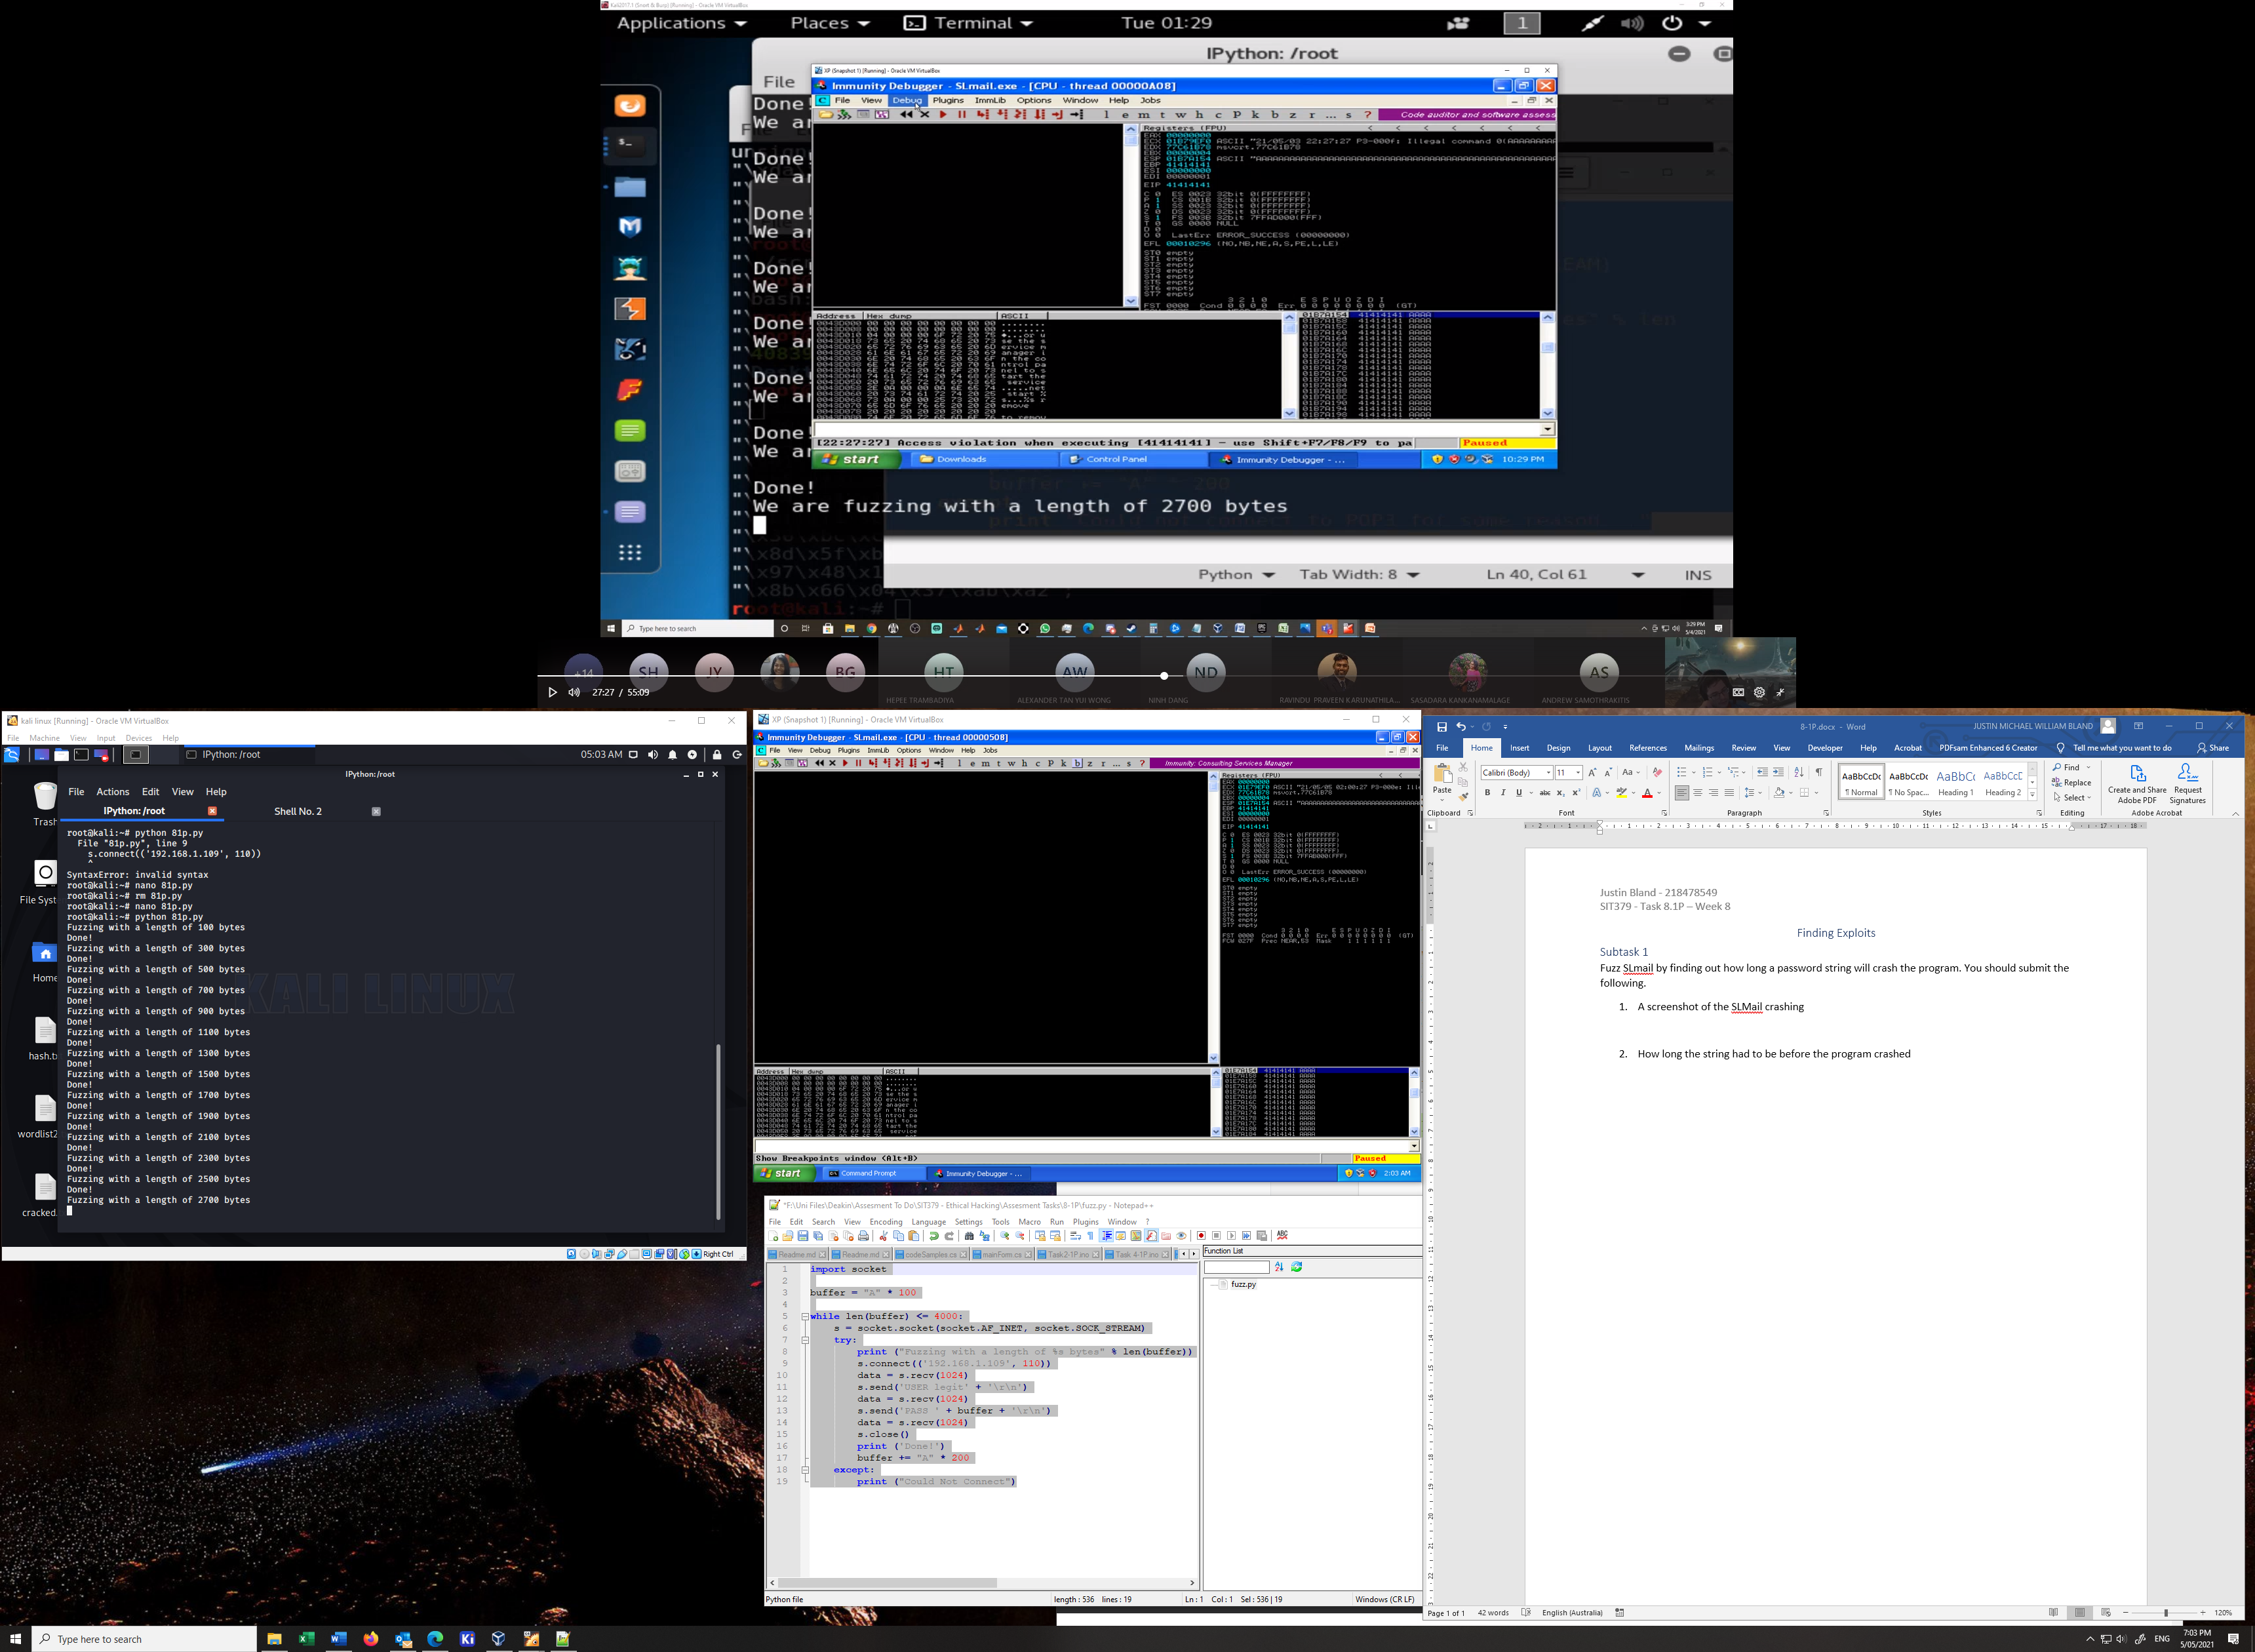

1. How long the string had to be before the program crashed

The password string was 2700 bytes long at the point of failure and using the pattern create/offset method we can see that the string has to be 2606 bytes long